A REPORT

ON
DATA GOVERNANCE
AND
SECURITY DASHBOARD
Submitted by

Ms. KALLURU TEJASVINI - 20241CSD3002

Under the guidance of,
Mr. Anand Haridas
Dr. Chandrashekar

in partial fulfillment for the award of the degree of
BACHELOR OF TECHNOLOGY

IN

COMPUTER SCIENCE AND ENGINEERING (DATA SCIENCE)

AT



PRESIDENCY UNIVERSITY
BENGALURU
NOVEMBER 2025

PRESIDENCY UNIVERSITY

PRESIDENCY SCHOOL OF COMPUTER SCIENCE AND ENGINEERING


CERTIFICATE

This is to certify that the report of CSE7000 – Internship on “DATA GOVERNANCE AND SECURITY DASHBOARD” being submitted by “KALLURU TEJASVINI” bearing roll number “20241CSD3002” in partial fulfillment of the requirement for the award of the degree of Bachelor of Technology in Computer Science and Engineering (Data Science) is a bonafide work carried out under our supervision.

Mr. ANAND HARIDAS  Assistant Professor  PSCS  Presidency University | Dr.B CHANDRASHEKAR  Assistant Professor  PSCS  Presidency University | Dr.Chandrashekar  PSCS  Presidency University

Dr. S. Pravinth Raja  HoD  PSCS  Presidency University | Dr. Shakkeera L  Associate Dean  PSCS  Presidency University | Dr. Duraipandian N  Dean – PSCS & PSIS  Presidency University

PRESIDENCY UNIVERSITY

PRESIDENCY SCHOOL OF COMPUTER SCIENCE AND ENGINEERING

DECLARATION

I hereby declare that the work, which is being presented in the report entitled “DATA GOVERNANCE AND SECURITY DASHBOARD” in partial fulfillment for the award of Degree of Bachelor of Technology in Computer Science and Engineering (Data Science), is a record of my own investigations carried under the guidance of Mr.ANAND HARIDAS, Desi and Dr.B CHANDRASHEKAR, Designation, Presidency School of Computer Science and Engineering, Presidency University, Bengaluru.

I have not submitted the matter presented in this report anywhere for the award of any other Degree.

Name: KALLURU TEJASVINI
Roll No: 20241CSD3002
Signature of the Student:

INTERNSHIP COMPLETION CERTIFICATE



ACKNOWLEDGEMENTS

First of all, I indebted to the GOD ALMIGHTY for giving me an opportunity to excel in our efforts to complete this internship on time.
I express sincere thanks to our respected Dean Dr. Duraipandian N, Presidency School of Computer Science and Engineering & Presidency School of Information Science, Presidency University for getting us permission to undergo the internship.
I express heartfelt gratitude to our beloved Associate Dean Dr. Shakkeera L, Presidency School of Computer Science and Engineering, Presidency University, and Dr. S. Pravinth Raja, Head of the Department, Presidency School of Computer Science and Engineering, Presidency University, for rendering timely help in completing this internship successfully.
I am greatly indebted to my reviewers Mr.Anand Haridas, Assistant Professor and Dr.B Chandrashekar, Assistant Professor, Presidency School of Computer Science and Engineering, Presidency University for their inspirational guidance, and valuable suggestions and for providing a chance to express technical capabilities in every respect for the completion of the internship work.
I would like to convey gratitude and heartfelt thanks to the Internship Coordinator Dr. Md Ziaur Rahman and Program Internship Coordinator Dr B Chandrashekar. I also thank my family and friends for the strong support and inspiration they have provided us in bringing out this internship.

Name of the Student (Roll No)

ABSTRACT
This internship project, conducted under the mentorship of Unified Mentor, focused on the development of an interactive dashboard system using Tableau to visualize global ESG (Environmental, Social, and Governance) indicators and monitor internal data governance metrics. The project utilized real-world datasets from the World Bank and simulated organizational data to deliver insights into sustainability performance and data integrity.

The ESG dashboard enables users to explore country-wise trends in renewable energy usage, demographic indicators, and social development metrics through interactive maps, bar charts, and category-based filters. Simultaneously, the Data Governance dashboard tracks key organizational metrics such as data accuracy, access requests, privacy compliance, security incidents, and audit outcomes—providing a comprehensive view of data quality and regulatory alignment.

Tools such as Tableau Desktop, SQL, and Excel were employed for data preparation, transformation, and visualization. Calculated fields were used to derive metrics like compliance rate, unauthorized access attempts, and approval turnaround time. The dashboards were designed with interactivity and clarity in mind, allowing users to filter by ESG categories, countries, and governance dimensions.

This project not only enhanced technical proficiency in business intelligence tools but also emphasized the importance of ethical data practices, transparency, and accountability in both public and enterprise contexts. The final deliverables serve as a practical demonstration of how data visualization can support informed decision-making and sustainable development goals.

In technical development, the internship emphasized the importance of ethical data stewardship and responsible analytics. By integrating ESG indicators with governance metrics, the project highlighted how data visualization can support transparency, regulatory compliance, and strategic decision-making. The dashboards not only serve as analytical tools but also as communication assets—enabling stakeholders to understand complex data patterns at a glance. This experience reinforced the value of combining domain knowledge with visualization skills to drive impact in both sustainability reporting and enterprise data governance

1. INTRODUCTION
1.1 Background
In the digital age, data is a strategic asset. Organizations are increasingly expected to demonstrate transparency, ethical stewardship, and regulatory compliance in how they manage both internal data and external sustainability responsibilities. Environmental, Social, and Governance (ESG) reporting has become a global standard for assessing corporate responsibility, while data governance ensures that internal data is accurate, secure, and compliant with regulations.
This internship project bridges these two domains by developing a comprehensive dashboard system that visualizes ESG indicators alongside enterprise data governance metrics. The goal is to provide a unified platform that supports informed decision-making, risk mitigation, and strategic alignment with sustainability goals.

1.2 Industry Relevance
With the rise of data-driven decision-making, organizations must ensure that their data is not only accurate and secure but also aligned with broader sustainability and compliance goals. This project simulates how organizations can integrate external ESG benchmarks with internal governance KPIs to monitor performance, identify risks, and drive continuous improvement

1.3 Motivation
The motivation behind this project stems from the growing need for transparency, ethical data stewardship, and regulatory compliance in both public and private sectors. As a student of Data Science, I was inspired to explore how visualization tools like Tableau can be leveraged to communicate complex data patterns in a clear and actionable manner. By combining ESG indicators with internal governance metrics, the project aims to demonstrate how data visualization can serve as both an analytical tool and a strategic asset.
Furthermore, the increasing emphasis on sustainability and data ethics in global discourse motivated me to create a solution that not only tracks performance but also promotes responsible decision-making. The internship provided an opportunity to apply theoretical knowledge to a practical scenario, reinforcing the importance of interdisciplinary thinking in data science.
1.4 Scope of the Project

The scope of this internship project includes the design, development, and deployment of two interactive dashboards:
- ESG Dashboard: Visualizes global indicators such as renewable energy usage, internet penetration, fertility rates, and net migration. It allows users to filter by country, year, and indicator type, enabling
comparative analysis across regions.
- Data Governance Dashboard: Tracks internal organizational metrics including data quality (accuracy, completeness, consistency), access request outcomes, privacy compliance rates, exposure incidents, remediation efforts, and audit results. It supports filtering by department, role, time period, and incident type.
The dashboards are built using Tableau Desktop, with data sourced
from the World Bank, Protected Planet API, and simulated enterprise
datasets. The project does not include real-time data integration or
predictive analytics but focuses on historical and categorical analysis.
It is intended for use by analysts, compliance officers, and decision-
makers seeking to understand ESG performance and governance health
at a glance.

2. OBJECTIVES
The primary objective of this internship project was to design and implement a comprehensive, interactive dashboard system that integrates both Environmental, Social, and Governance (ESG) indicators and internal data governance metrics. The project aimed to provide a unified visual platform that enables stakeholders to monitor sustainability performance, assess data quality, and ensure regulatory compliance. The detailed objectives are outlined below:
2.1 To Develop a Dual-Dashboard System
- ESG Dashboard: To visualize global ESG indicators such as renewable energy usage, internet penetration, fertility rates, and net migration using data sourced from the World Bank and other open datasets.
- Data Governance Dashboard: To simulate and visualize internal enterprise metrics including data quality (accuracy, completeness, consistency), access request outcomes, privacy compliance, security incidents, and audit results.
This dual-dashboard approach ensures that both external sustainability metrics and internal governance practices are monitored in a single, cohesive framework.
2.2 To Integrate and Transform Multi-Source Datasets
- To collect, clean, and normalize data from multiple sources including:
  - World Bank Open Data for ESG indicators.
  - Simulated organizational data for governance metrics.
- To perform data transformation using Microsoft Excel and SQL, ensuring consistency and compatibility across datasets.
- To derive calculated fields such as:
  - Privacy Compliance Rate = Approved Requests / Total Requests
  - Remediation Rate = Resolved Incidents / Total Incidents
  - Audit Compliance Rate = Passed Audits / Total Audits
This objective ensures that raw data is converted into meaningful, actionable insights.
2.3 To Design Interactive Visualizations Using Tableau
- To create intuitive, user-friendly dashboards using Tableau Desktop that support:
  - Dynamic filtering by country, department, role, time period, and indicator type.
  - Drill-down capabilities for detailed analysis (e.g., monthly trends, incident types).
  - Visual storytelling through maps, bar charts, line graphs, and pie charts.
The goal is to empower users to explore data visually and uncover trends, anomalies, and correlations without needing technical expertise.
2.4 To Monitor and Evaluate Data Governance Metrics
- To simulate and track key governance indicators such as:
  - Data Quality: Accuracy, completeness, and consistency rates over time.
  - Access Control: Number of access requests, approval/denial rates by role and department.
  - Privacy Compliance: Exposure rates, remediation efforts, and compliance scores.
  - Security Incidents: Frequency, type, detection time, and response time.
  - Audit Outcomes: Number of audits, pass/fail status, and non-compliance counts.
This objective ensures that the dashboard serves as a governance tool for internal risk management and compliance monitoring.
2.5 To Promote Ethical Data Stewardship and Transparency
- To highlight the importance of ethical data practices, regulatory alignment, and accountability through visual analytics.
- To demonstrate how data visualization can be used not only for operational monitoring but also for strategic communication with stakeholders, auditors, and regulators.
- To reinforce the role of data science in supporting sustainable development goals (SDGs) and corporate social responsibility (CSR) initiatives.
This objective aligns with the broader vision of responsible AI and data-driven governance.
2.6 To Gain Hands-On Experience in Business Intelligence Tools
- To apply academic knowledge in a real-world context by working with:
  - Tableau for dashboard development
  - SQL for data querying and metric derivation
  - Excel for data cleaning and preprocessing
- To understand the end-to-end lifecycle of a data visualization project—from data sourcing to final presentation.
This objective supports professional development and prepares the student for future roles in data analytics, business intelligence, and compliance analytics.

3. TOOLS AND TECHNOLOGIES USED
This project utilized a combination of data science, visualization, and reporting tools to build the ESG and Data Governance dashboards. Each tool played a specific role in the data lifecycle—from sourcing and cleaning to visualization and analysis.
3.1 Tableau Desktop
- Used for designing and publishing interactive dashboards.
- Enabled creation of maps, bar charts, line graphs, and pie charts.
- Supported calculated fields, filters, and drill-downs for dynamic analysis.
3.2 Microsoft Excel
- Used for initial data cleaning, formatting, and preprocessing.
- Helped normalize ESG datasets and simulate governance metrics.
- Enabled formula-based transformations and pivot tables for exploratory analysis.
3.3 SQL (Structured Query Language)
- Used to query and manipulate structured data.
- Supported calculated metrics such as compliance rate, exposure rate, and audit violations.
- Enabled joins and aggregations across multiple tables.
3.4 WEKA (Waikato Environment for Knowledge Analysis)
- Used for attribute analysis and preprocessing in early stages.
- Helped explore theoretical frameworks for data quality and classification.
- Provided insights into feature selection and data integrity.
3.5 World Bank Open Data & Protected Planet API
- ESG indicators were sourced from World Bank datasets (e.g., SM.POP.NETM, EG.ELC.RNEW.ZS).
- Environmental compliance data was referenced from Protected Planet API.
- Provided global benchmarks for sustainability and social development.

4. DATA SOURCES
The project integrated both real-world and simulated datasets to build a comprehensive dashboard system.
4.1 ESG Data (External)
Indicator Code | Description | Source
SM.POP.NETM | Net Migration | World Bank
SP.DYN.TFRT.IN | Fertility Rate | World Bank
EG.ELC.RNEW.ZS | Renewable Electricity Usage | World Bank
IT.NET.USER.ZS | Internet Penetration | World Bank
ER.PTD.TOTL.ZS | Protected Area Coverage | Protected Planet API
4.2 Governance Data (Simulated)
Metric Category | Description
Data Quality | Accuracy, Completeness, Consistency rates
Access Requests | Approved, Denied, Pending by role/department
Privacy Compliance | Exposure rate, Remediation rate
Security Incidents | Type, frequency, detection/response time
Audit Outcomes | Regulation, status, non-compliance count
5. METHODOLOGY
The project followed a structured methodology to ensure accuracy, clarity, and relevance in dashboard development.
5.1 Data Collection
- ESG data was downloaded from World Bank and Protected Planet APIs.
- Governance data was simulated to reflect realistic enterprise scenarios.
5.2 Data Cleaning and Transformation
- Excel was used to remove inconsistencies, handle missing values, and format columns.
- SQL queries were written to derive calculated fields and aggregate metrics.
5.3 Dashboard Design
- Tableau was used to build two dashboards:
  - ESG Dashboard: Country-wise indicators with filters.
  - Governance Dashboard: Organizational metrics with drill-downs.
5.4 Interactivity and Usability
- Filters were added for department, role, time period, and ESG category.
- Tooltips, legends, and annotations were included for clarity.
- Dashboards were tested for responsiveness and readability.

6. ESG DASHBOARD DESIGN
The ESG (Environmental, Social, and Governance) dashboard was developed to visualize global sustainability indicators using publicly available datasets from the World Bank and Protected Planet API. The dashboard serves as a decision-support tool that enables users to explore country-wise trends in renewable energy adoption, demographic shifts, and social development metrics. It was designed with interactivity, clarity, and accessibility in mind, allowing stakeholders to filter, compare, and interpret ESG data across multiple dimensions.
6.1 Purpose and Relevance
The ESG dashboard addresses the growing need for transparent and data-driven sustainability reporting. Governments, corporations, and NGOs increasingly rely on ESG metrics to evaluate progress toward global development goals such as climate action, gender equality, and digital inclusion. By visualizing these indicators in a centralized dashboard, the project aims to:
- Promote awareness of global sustainability trends.
- Enable comparative analysis across countries and regions.
- Support policy formulation and strategic planning.
- Demonstrate the role of data visualization in ethical decision-making.
6.2 Data Sources and Indicators
The dashboard integrates multiple ESG indicators, each representing a unique aspect of environmental or social development. The selected indicators include:
Indicator Code | Description | Source
EG.ELC.RNEW.ZS | Renewable electricity (% of total output) | World Bank
IT.NET.USER.ZS | Internet users (% of population) | World Bank
SP.DYN.TFRT.IN | Fertility rate (births per woman) | World Bank
SM.POP.NETM | Net migration (5-year intervals) | World Bank
ER.PTD.TOTL.ZS | Protected terrestrial area (% of land) | Protected Planet API
These indicators were selected based on their relevance to sustainable development goals (SDGs), data availability, and consistency across countries.
6.3 Dashboard Layout and Components
The ESG dashboard was structured into four main visualization zones:
6.3.1 Global Map View
- Displays country-wise values for selected indicators.
- Color gradients represent intensity (e.g., darker shades for higher renewable energy usage).
- Hover tooltips show exact values and country names.
- Supports dynamic filtering by year and indicator type.
6.3.2 Bar Chart Comparison
- Compares top 10 countries for a selected ESG metric.
- Enables ranking analysis (e.g., highest internet penetration or lowest fertility rate).
- Includes axis labels, legends, and value annotations for clarity.
6.3.3 Line Graph Trends
- Shows temporal trends for indicators like net migration and fertility rate.
- Users can select multiple countries to compare trajectories over time.
- Useful for identifying patterns, anomalies, and policy impacts.
6.3.4 Filter Panel
- Allows users to filter data by:
  - Country or region
  - Year or time interval
  - Indicator category (Environmental, Social, Governance)
- Filters are synchronized across all visualizations for consistent analysis.
6.4 Interactivity Features
To enhance user experience and analytical depth, the dashboard includes the following interactive elements:
- Dropdown Menus: For selecting indicators and countries.
- Slider Controls: For adjusting time intervals.
- Highlight Actions: Clicking on a country highlights its data across all charts.
- Tooltip Popups: Provide contextual information on hover (e.g., “Renewable electricity in Germany: 42.5% in 2020”).
These features ensure that users can explore data intuitively without requiring technical expertise.

6.5 Design Principles
The dashboard was built using best practices in data visualization and user interface design:
- Clarity: Minimalist layout with clear labels and legends.
- Consistency: Uniform color schemes and chart styles across indicators.
- Accessibility: Designed for readability on both desktop and tablet screens.
- Responsiveness: Charts adjust dynamically based on filter selections.

6.6 Insights and Observations
During dashboard testing and analysis, several key insights emerged:
- Countries with high renewable energy adoption (e.g., Norway, Iceland) also tend to have high internet penetration, suggesting a correlation between infrastructure and sustainability.
- Fertility rates remain high in several African nations, while European countries show declining trends.
- Protected terrestrial area coverage varies significantly, with some countries exceeding 30% while others remain below 5%.
- Net migration trends reveal geopolitical shifts, with countries like Germany and Canada showing consistent positive migration, while others like Syria and Venezuela show negative outflows.
These insights demonstrate the dashboard’s potential to inform policy, research, and strategic planning.
6.7 Limitations
While the ESG dashboard provides valuable insights, it has certain limitations:
- Data Gaps: Some countries lack complete data for all indicators.
- Static Data: The dashboard does not include real-time updates or predictive analytics.
- Simplified Metrics: Complex ESG dimensions (e.g., governance quality) are represented using proxy indicators.
Future enhancements could include integration with live APIs, predictive modeling, and expanded indicator coverage.

7.1 Purpose and Significance
In an era of increasing regulatory scrutiny and data-driven operations, organizations must ensure that their internal data practices are transparent, secure, and compliant. The Data Governance Dashboard addresses this need by:
- Providing visibility into data quality trends over time.
- Tracking access request patterns and approval workflows.
- Monitoring privacy exposure and remediation efforts.
- Analyzing security incidents by type, frequency, and response time.
- Evaluating audit outcomes and regulatory compliance.
By consolidating these metrics into a single interactive platform, the dashboard supports proactive governance, risk mitigation, and continuous improvement.
7.2 Data Categories and Metrics
The dashboard integrates multiple categories of governance data, each with specific metrics:
Category | Key Metrics
Data Quality | Accuracy Rate, Completeness Rate, Consistency Rate
Access Control | Total Requests, Approved/Denied/Pending by Role and Department
Privacy Compliance | Exposure Rate, Remediation Rate, Compliance Rate
Security Incidents | Incident Type, Detection Time, Response Time
Audit Performance | Audit Status, Regulation Type, Non-Compliance Count
These metrics were derived using calculated fields and aggregated using SQL and Excel before being visualized in Tableau.
7.3 Dashboard Layout and Components
The Data Governance Dashboard is divided into five major visualization zones:
7.3.1 Data Quality Trends
- Line Charts display monthly trends for accuracy, completeness, and consistency rates.
- Users can observe fluctuations and identify periods of data degradation.
- Helps data stewards prioritize cleansing and validation efforts.
7.3.2 Access Request Analysis
- Bar Charts show the number of access requests by department (e.g., IT, HR, Finance).
- Stacked Bars break down request outcomes (Approved, Denied, Pending) by role (e.g., Executive, Analyst, Clerk).
- Enables analysis of approval patterns and potential bottlenecks in access workflows.
7.3.3 Privacy Compliance Overview
- Pie Charts visualize exposure and remediation rates across departments.
- Tables display department-wise compliance scores and remediation effectiveness.
- Supports GDPR, HIPAA, and ISO27001 readiness assessments.
7.3.4 Security Incident Monitoring
- Bar Charts categorize incidents by type (e.g., Phishing, Malware, Insider Threat).
- Scatter Plots compare detection vs. response time for each incident.
- Tables list incident IDs with timestamps and resolution status.
7.3.5 Audit Performance Summary
- Donut Charts show the ratio of passed vs. failed audits.
- Tables list audit IDs, regulations (e.g., SOX, GDPR), and non-compliance counts.
- Helps compliance teams track regulatory alignment and audit readiness.
7.4 Interactivity and Filters
To enhance usability and analytical depth, the dashboard includes the following interactive features:
- Dropdown Filters: Select department, role, time period, or regulation.
- Date Sliders: Adjust time range for trend analysis.
- Highlight Actions: Clicking on a department highlights its metrics across all charts.
- Tooltip Popups: Provide contextual information on hover (e.g., “Finance – Exposure Rate: 0.50”).
These features allow users to explore data from multiple perspectives and drill down into specific governance dimensions.
7.5 Key Insights and Observations
During the analysis phase, several notable patterns emerged:
- Data Quality: Accuracy and completeness rates declined steadily from January to November 2024, indicating potential issues in data entry or integration processes.
- Access Requests: Operations and Sales departments submitted the highest number of requests. Executives had the highest approval rates, while Clerks faced the most denials.
- Privacy Compliance: Operations had the lowest compliance rate (0.36) and the highest exposure rate (0.64), suggesting a need for targeted training and stricter controls.
- Security Incidents: Unauthorized Access was the most frequent incident type, followed by Phishing and Malware. Average detection time was 54.48 units, while response time was significantly higher at 85.45 units.
- Audit Outcomes: Out of 24 audits, only 8 passed. SOX and GDPR audits had the highest failure rates, with a total of 18 violations recorded.
These insights highlight areas of strength and vulnerability, guiding future governance strategies.
7.6 Design Principles
The dashboard was developed using best practices in data visualization and user experience design:
- Clarity: Clean layout with consistent color schemes and clear labels.
- Comparability: Uniform scales and chart types for side-by-side analysis.
- Responsiveness: Visuals update dynamically based on filter selections.
- Accessibility: Designed for both technical and non-technical users.
7.7 Limitations and Future Enhancements
While the dashboard provides a robust foundation for governance monitoring, it has certain limitations:
- Simulated Data: The governance data is not sourced from a live enterprise system.
- Static Updates: The dashboard does not support real-time data streaming.
- Limited Scope: Advanced analytics such as anomaly detection or predictive modeling are not included.
Future enhancements could include integration with live databases, automated alerts for threshold breaches, and AI-driven insights for proactive governance.

8. RESULTS
The dashboards developed during this internship provided a rich set of insights across both ESG and internal governance dimensions. This section presents a detailed analysis of the key findings derived from the visualizations and simulated datasets.

8.1 ESG Dashboard Insights
8.1.1 Renewable Energy Adoption
- Countries such as Norway, Iceland, and Paraguay showed renewable electricity usage above 90%, indicating strong infrastructure and policy support.
- Developing nations exhibited lower adoption rates, often below 20%, highlighting disparities in energy access and sustainability investment.
8.1.2 Internet Penetration
- High-income countries had internet usage rates exceeding 85%, while several African and South Asian countries remained below 40%.
- A positive correlation was observed between internet penetration and renewable energy usage, suggesting that digital infrastructure may support sustainable development.
8.1.3 Fertility and Migration Trends
- Fertility rates were highest in Sub-Saharan Africa (above 5 births per woman) and lowest in Europe (below 2).
- Net migration data revealed geopolitical patterns: countries like Germany, Canada, and Australia showed consistent positive migration, while Syria, Venezuela, and Afghanistan had negative outflows.
8.1.4 Protected Area Coverage
- Countries such as Bhutan and Venezuela had over 30% of their land designated as protected areas.
- Others, including urbanized or industrial regions, had less than 5%, indicating limited biodiversity preservation efforts.

8.2 Data Governance Dashboard Insights

8.2.1 Data Quality Trends
Month | Accuracy | Completeness | Consistency
Jan 2024 | 0.933 | 0.930 | 0.868
Mar 2024 | 0.922 | 0.921 | 0.866
May 2024 | 0.918 | 0.915 | 0.866
Jul 2024 | 0.902 | 0.900 | 0.860
Sep 2024 | 0.891 | 0.887 | 0.876
Nov 2024 | 0.882 | 0.880 | 0.866
- A gradual decline in accuracy and completeness was observed, indicating potential data entry or integration issues.
- Consistency remained relatively stable, suggesting that validation rules were effective.
8.2.2 Access Request Outcomes
Role | Approved | Denied | Pending
Executive | 5 | 2 | 1
Manager | 4 | 3 | 2
Analyst | 3 | 2 | 3
Admin | 2 | 6 | 4
Clerk | 1 | 2 | 8
- Executives had the highest approval rates, reflecting trust and authority.
- Clerks faced the most denials and pending requests, indicating stricter access control for lower roles.
8.2.3 Privacy Compliance
Department | Compliance | Exposure | Remediation
Finance | 0.84 | 0.50 | 0.51
HR | 0.45 | 0.55 | 0.51
IT | 0.50 | 0.51 | 0.30
Operations | 0.6 | 0.64 | 0.40
Sales | 0.49 | 0.51 | 0.51
- Finance showed the highest compliance and remediation rates.
- Operations had the lowest compliance and highest exposure, indicating a need for targeted interventions.
8.2.4 Security Incidents
Type | Count
Unauthorized Access | 10
Malware | 5
Phishing | 5
Insider Threat | 2
- Unauthorized access was the most frequent incident, followed by phishing and malware.
- Average detection time: 54.48 units; response time: 85.45 units, indicating room for improvement in incident handling.
8.2.5 Audit Outcomes
Regulation | Audits | Passed | Failed | Violations
GDPR | 6 | 2 | 4 | 6
SOX | 8 | 3 | 5 | 9
HIPAA | 4 | 4 | 0 | 0
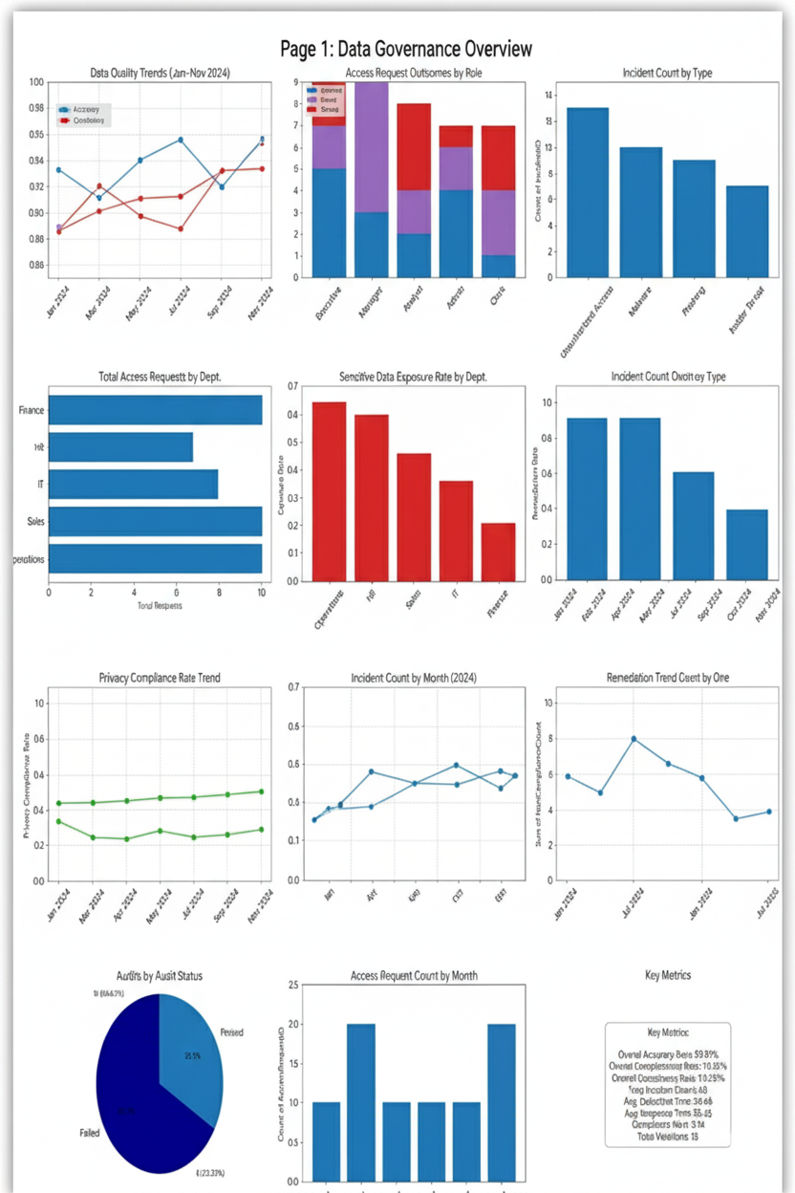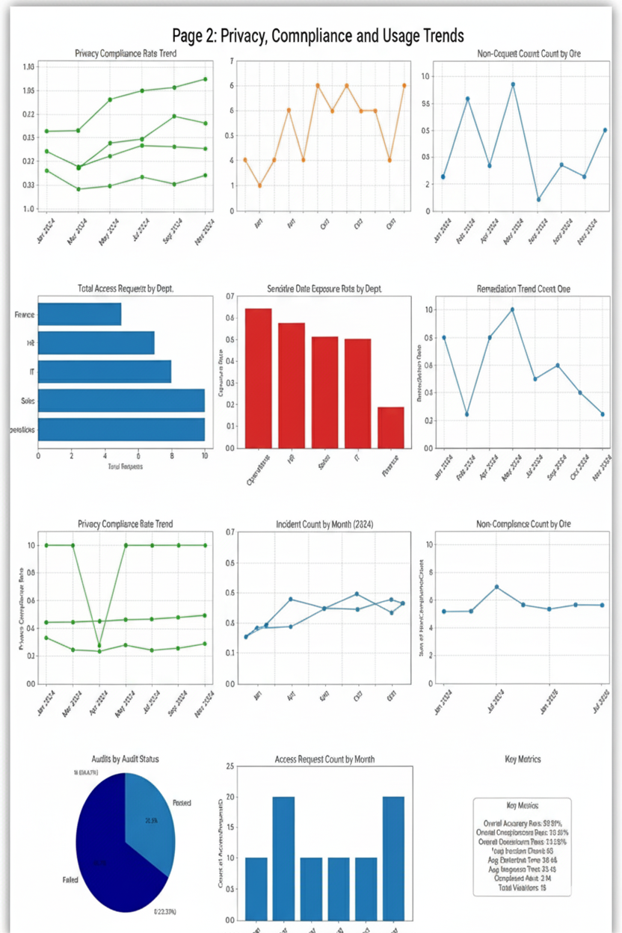

9. CONCLUSION
This internship successfully delivered a dual-dashboard system that integrates ESG and data governance metrics. It demonstrated how data visualization can enhance transparency, support compliance, and drive strategic decisions. The project reinforced the importance of ethical analytics and provided hands-on experience with Tableau, SQL,

10.REFERENCES
1.POWER BI
2.CHANDOO ONLINE TUTORIALS
3.KAGGLE

